Luke Leiter

CMPSC 475

Project Report

12-16-2021

**Home Quartermaster**

Sometimes keeping track of all our stuff can be time consuming and stressful. Especially when we must remember what need upkeep and when. For example, my dad has often forgotten if he owns a tool and where it would be. Sometimes he might by a second tool he already owns and not even know it! Another example to demonstrate my problem is my car. While I don’t loose my car it does need maintenance done. Between my wife’s car and my car I don’t always remember which is taken care of. Last year I forgot to renew my registration and got a ticket as a result. My app would help keep track of things the user owns. There are apps that allow the user to save lists of items they own and even in what room, but this is focused on the organization aspect. Airbnb owners also use these apps to keep track of different properties they own and what is in them. The user can create items and give them a description, putting in any information they choose to. The data will be created and accessed by the user through various activities and fragments. The name comes from a position I held when I was in Boy Scouts. The Quartermaster of the troop kept record of the troops gear and what maintenance needed done. This app is a Quartermaster for the home, the Home Quartermaster. This use case diagram shows the main uses of the app in it’s current state.

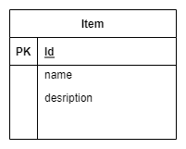This is an Entity Relation Diagram shows that the database is very simple.

The user will create this data through a from the app provides to them. The names and description of entities will be text boxes.

These are all the fragments to user will interact with. The plus button will add a new Item when in the Item List Fragment (the beginning fragment). Clicking on the item will allow the user to see more details on the items in addition to allowing them to create more actions for an item.

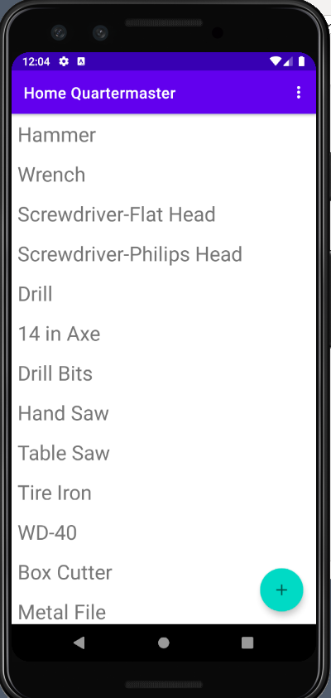

The list of Items, Item description, and the form to create a new item are all different fragments of the same activity. The recycler view can be used when the user has too many items to be displayed on one screen. The data will be stored in a database which will be accessed with Room. These are the requirements Home Quartermaster has fulfilled. I did not allot enough time to complete an authentication component. Subsequently the app does not store the user’s data in the cloud as I had planned to use the users google account to store that data. The app bar menu item is partially complete; the settings option is there but I did not create a fragment for it yet.